**Year 5 Homework - Friday 16th May 2025**

In Literacy we are currently reading a fantastic book called ‘The Wolves of Willoughby Chase’. To help us with writing non-chronological reports next week linking to this, can you use a dictionary or the internet to find out the definitions of the technical vocabulary below?

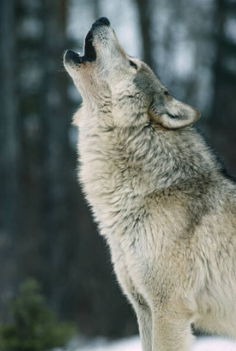

Alpha male –

Beta Male –

Camouflage –

Carnivores –

Dominant –

Hierarchy –

Mammals –

Pack –

Predator -

Prey-

**Homework due in – Friday 23rd May 2025**

